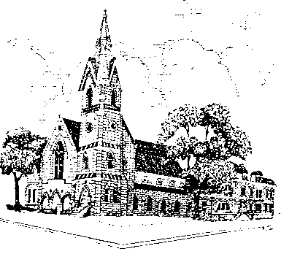
TABERNACLE BAPTIST CHURCH

COMMUNITY SERVICE APPLICATION

Name: Date:

Address: Phone:
Cell Phone:
City: State: Zip Code:
Date of Birth: Grade:
Reason for Community Service: Jr High Class:
Sr. High Class:

Name of School:
Name of Teacher :

Other reason for community service:

Number of Community Service Hours required:

Date range of required Hours: thru

************************************************************************

Community Service Pledge:

During the hours served at Tabernacle Baptist Church I pledge to:
- Demonstrate an interest in the experience
- Cooperate with all persons involve
- Adhere to all rules and regulations
- Act in an ethical manner at all times
- Inform my supervisor in the event of an illness or emergency
- Be Punctual

____________________________________________________
Signature of Student / Volunteer

